

System Maintenance and Technical Document (SMTD)
Machine Optimizer Pre-process
Version 1.0

Document Details
Prepared by/Date | Reviewed by/Date | Approved by/Date
Neil Sibug/ 01 Mar. 16
Revision History
Version | Date of Revision | Description of Change | Reason for Change | Affected Sections | Approved By
Draft
Affected Groups

1. Scope and Purpose 4
2. Application Overview 4
3. Business Processes 4
4. Application Access Procedure 4
5. Initial Status of the Application under Maintenance 4
5.1. Modules/Interfaces/Data structures 4
5.2. Documents 4
5.3. Standards and Guidelines 4
6. Application Environment 5
7. Affected Systems/Applications 5
8. User Interfaces 5
9. Application Design 5
9.1. Relation to External Systems 5
9.2. System / Sub-system Architecture 5
9.3. Inter-module Relationships 5
9.4. Application Modules 5
9.5. Database Details 6
10. Global Data Structures and Shared Data Functions 6
11. Critical Functions 6
11.1. Testing Strategies 6
11.2. Test Data 6
12. Reusable components 6
13. Limitations 6
14. References 6
15. Application History 7
15.1. Typical Problems 7
15.2. Release History 7
17. Learning 7

Terminology and Acronyms

Terminology/ Acronym | Definition
MSOPT | Machine Optimizer
Wrapper Script | Is the automated process to prepare input data or generate another report from the output data
MSOPT_DB | MySQL Optimizer database

Scope and Purpose
This document is intended to capture the information of the application as acquired during the training and parallel perform phases. This is an evolving document and will be updated through the training and parallel perform phases. The sections in this document indicate the type of information that would be typically required to carry out the support/development/test activities during the steady state. The scope of this document is to point to the relevant documents available with <CLIENT> that would be used by Wipro to support the steady state activities. In cases where there are no documents pertaining to the information required in the section, the Wipro engineers will include a brief description based on their learning.

Application Overview

MSOPT

Input Data
Wrapper Script
(Pre-process)

Input data
(Processed)

MSOPT Pre-process script is an automated external process for downloading and preparing the input data from a specific data repository. The raw data are downloaded from the repository and then it will be imported in the MSOPT_DB, after that the wrapper script will be triggered and process the data from the database. The output of the wrapper script is the processed input data in addition backup file are created during this process. Finally after pre-processing of all input data it will then be process into the Machine Optimizer.

Business Processes

Automated Task Schedule

Update TWSTATUS data

Download RTD Flat File

Download Input data

Pre-process wrapper script Input data

To prepare the Input data, there are several steps to be process within the Wrapper script; first is to update TWSTATUS data every hour. Then download some flat data file from the RTD, including the following (clatTester_StationStatus, TEST_NEXTLOTINFO, ATTSSTESTSPEC and TWSTATUS), from these set of files it will generate the SMSDW data. Next is to download the Input data from the network repository, all the critical data will then be transferred to the local Clark machine. Last but not the least is to process the pre-process script to generate a new set of input data from the original data.

Application Access Procedure

MSOPT Wrapper script
In accessing the wrapper script automated task schedule follow this steps.
- Go to Start>All Programs>RealVNC>VNC Viewer

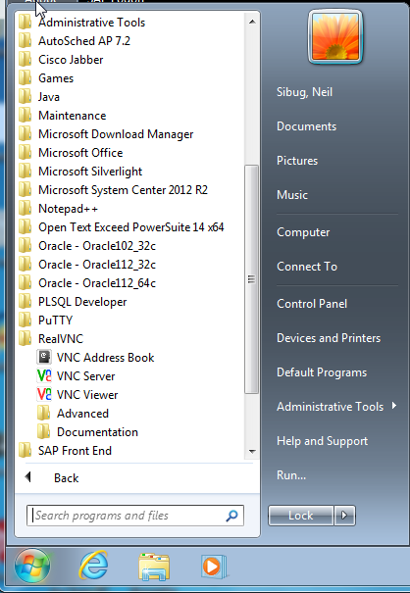

- Connect to CLARK workstation (CCLE0174881)

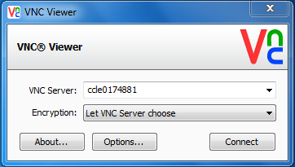

- From the Control Panel>System and Security>Administrative Tools; open the Task Scheduler

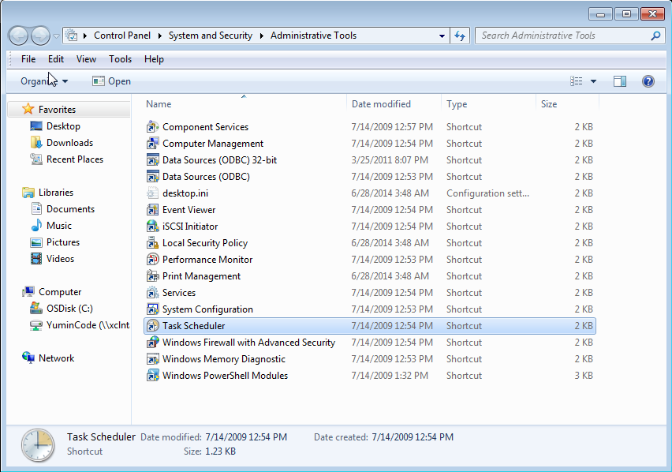

- From the Control Panel>System and Security>Administrative Tools; open the Task Scheduler

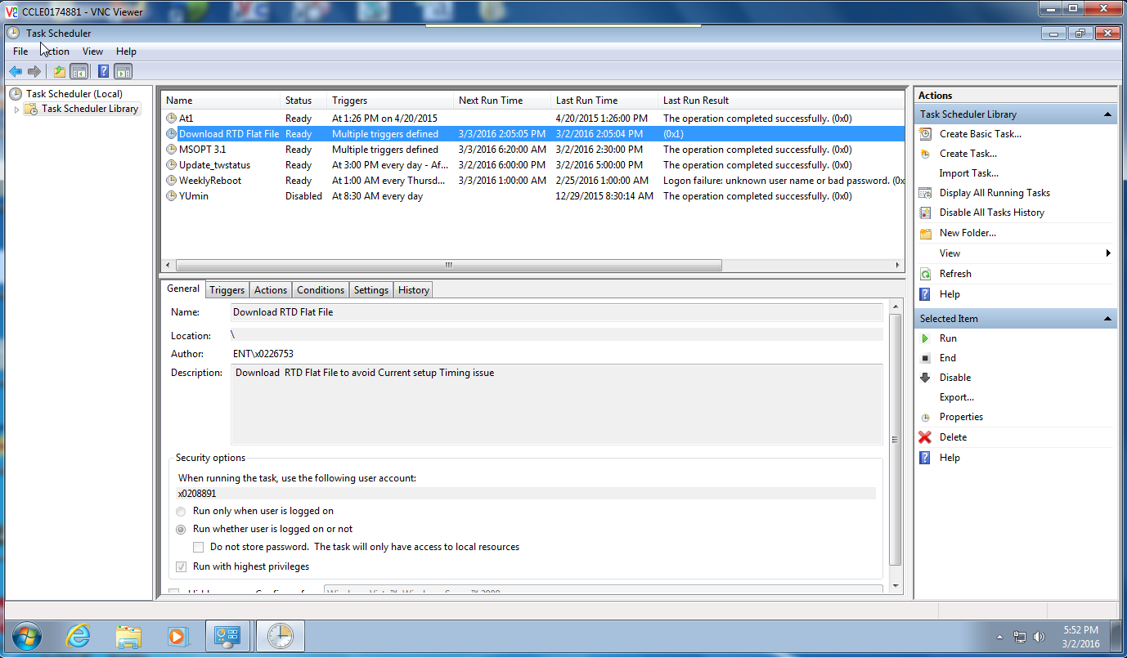
Fig. 1.4.a
Note: Check and verify the columns in each scheduled task (i.e. the Status and Last Run Time)

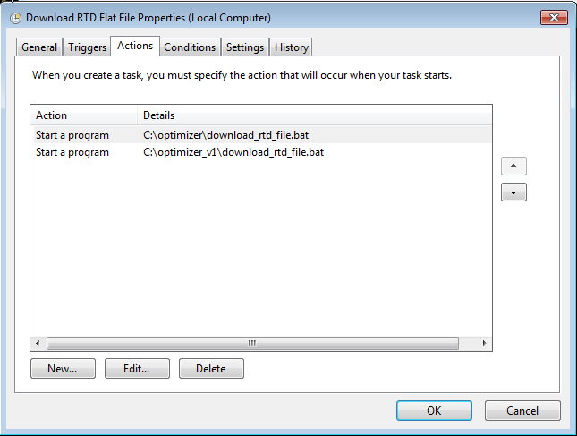
Fig. 1.4.b
Note: This window is the task that has been included on the Task Scheduler. You can check each task details by clicking the Tabs.

MSOPT batch file
To manually execute the MSOPT batch file

- Go to Start>All Programs>Accessories>Command Prompt

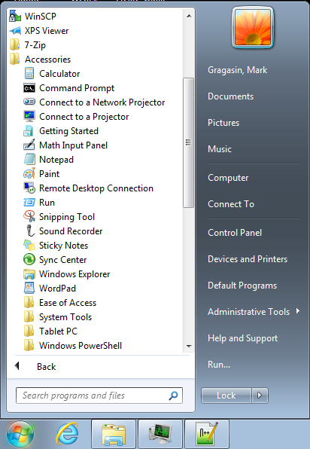

- From the Command Prompt, Go to MSOPT directory and execute the batch file. As seen in the figure below.
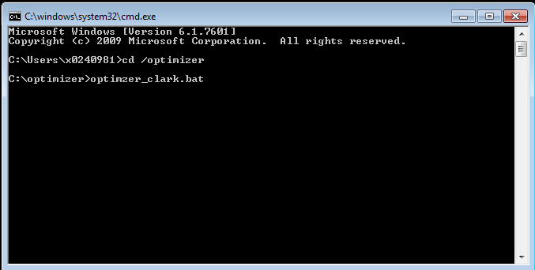
Fig. 2.2.a
Note: The MSOPT batch file may not be complete for the pre-process script; there are also external batch and scripting files to be run.

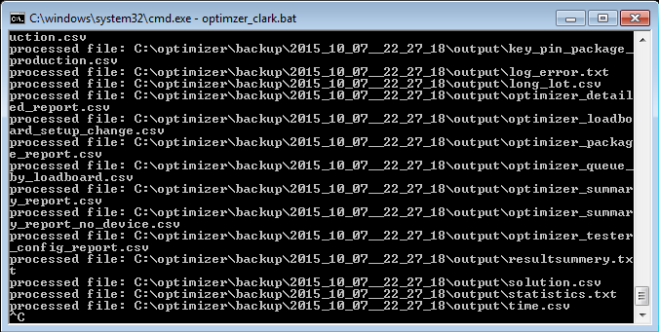
Fig. 2.2.b

MSOPT executable
To manually execute the MSOPT executable

- Go to Start>All Programs>Accessories>Command Prompt

- From the Command Prompt, Go to MSOPT directory and execute the batch file. As seen in the figure below.

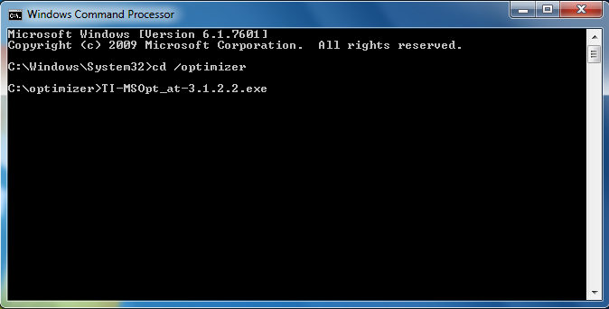
Fig. 2.3.a
Note: You can re-process the MSOPT executable on CLARK or your Local machine; simply copy the input data from the backup snapshot of CLARK workstation. Then run again the MSOPT exe.

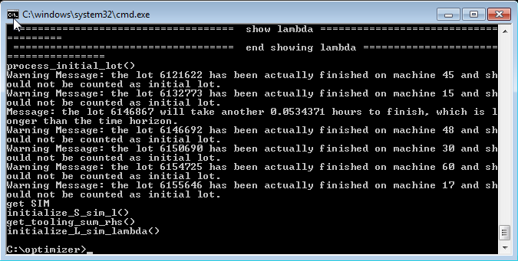
Fig. 2.3.b

Accessing the Input and Output data
To access the input and output data for MSOPT

- Go to Start>Computer

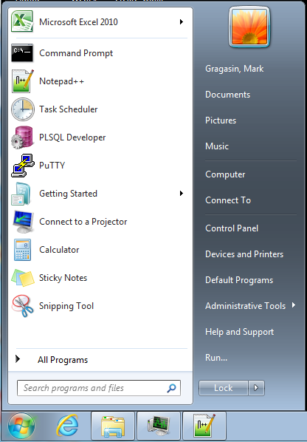
Fig. 3.1.a

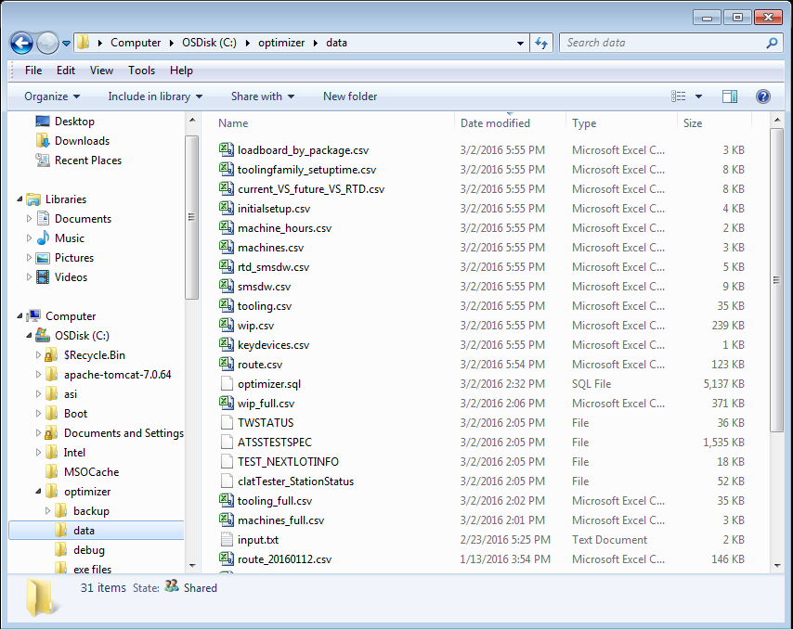
Fig. 3.1.b Input data

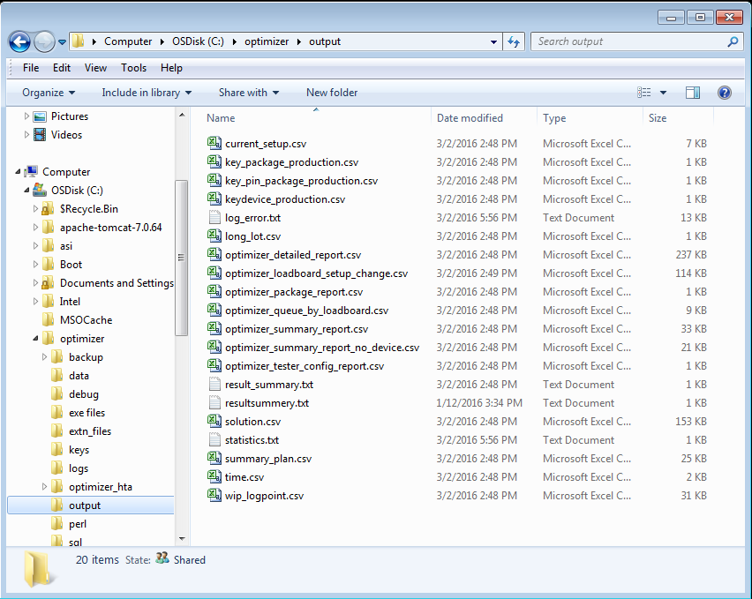
Fig. 3.1.c Output data

Initial Status of the Application under Maintenance

Modules/Interfaces/Data structures

MSOPT batch file

This file is the main program that calls every function used by MSOPT like the pre and post process, also for the MSOPT executable. The critical files to look at input data are the following:

- WIP
- Route
- Tooling
- Machine
- Key Devices
- Initial Setup

MSOPT executable

This executable file is the Machine Optimizer it is develop using C++, this programs tries to solved the machine-tooling combination shortage on the floor, by processing the data then generating the optimize solution for the floor.

Input and Output data

The input and output data for MSOPT is the critical files that program need and generate every successful run.

Input:
- Wip
- Machines
- Machine hours
- Route
- Tooling
- Tooling Family setup time\
- Key devices
- Key package
- Key pin package

Output:
- Solution
- Current setup
- Key package production
- Key pin package production
- Key device production
- Long lot
- Time
- Statistic
- Result summary
- Log error

Documents

Not applicable

Standards and Guidelines

Before the MSOPT runs, all files in the input data folder should be closed

Application Environment

Development Environment |  | Test Environment
Workstation: CBAE0132479 (Baguio Beta)  OS: Win XP  DBMS: MySQL, Oracle 11g  Script: SQL, VBScript, PERL, MS-DOS and C++ |  | Workstation: CCLE0174881 (Clark Beta Testing)  OS: Win XP  DBMS: MySQL, Oracle 11g  Script: SQL, VBScript, PERL, MS-DOS and C++
Staging Environment (optional) |  | Production Environment
Not applicable |  | Not applicable

Affected Systems/Applications

Affected System / Application | Responsibility  (Wipro/<CLIENT>/Other) | Contact Details
MSOPT (automated run) | TIPI Baguio | Neil Sibug/Mark Gragasin
Optimizer (MySQL) | TIPI Baguio | Neil Sibug/Mark Gragasin
TI-Clark FFW reporting | TIPI Baguio | Neil Sibug/Mark Gragasin

User Interfaces

Not applicable

Application Design

Relation to External Systems

TI-Clark FFW reporting is a web reporting tool for MSOPT.

System / Sub-system Architecture

Not applicable

Inter-module Relationships

Not Applicable

Application Modules

Module Name and Description
Not applicable

Design Details
Not applicable

Global Data Structure References
Not applicable

Module Specific Data Structures
Not applicable

Database Details
To be submitted

Batch Job Details

Daily Batch jobs

MSOPT automated runs:
Clark / Baguio
6:30 AM Asia time
2:30 PM Asia time
10:30 PM Asia time

Weekly Batch jobs

Clark workstation reboot
1:00 AM Asia time

Monthly Batch jobs
Not applicable

Quarterly Batch jobs
Not applicable

Global Data Structures and Shared Data Functions
Not applicable

Critical Functions

During the generation of the process

Testing Strategies
Note applicable

Test Data
Note applicable

SLAs & Service Patch Deployment

Configuration Management
Note applicable

Service Level Agreements (SLAs)
Note applicable

Maintenance and Service Patch Deployment Process
Note applicable

Emergency fix Management
Note applicable

Reusable components

Limitations

For now the system detects error and sends notification, it cannot resolve yet if some errors occur during processing. Also if the data sources are having a problem to produce an input data, there is no way the MSOPT can continue its run.

Business continuity & Disaster recovery plan

Disaster Recovery Process

If the beta-testing in Clark fails and need some time to be operational again, we have a backup environment readily available for MSOPT.

Vital Records
(This sub-section lists all the vital records produced and needed by the application)

Please refer to the Limitation section.

References
Please refer to the MSOPT link https://itsps.itg.ti.com/sites/fss/msopt/default.aspx

Application History

Typical Problems

During the automated runs, we usual encounter an error that causes the MSOPT to fail. In addition most of the error are relates back in the input data, one of the common issue is the data mismatch on the input data.

Release History
There are several versions for MSOPT project; however we are current using the version 3 series.

MSOPT version 1
MSOPT version 2
MSOPT version 3
MSOPT version 4

17. Learning

